**Metrics, UA/TA, Design Rationale** Patrick

**User Testing** Ian

**Icon design** Jules

moqups.com for storyboard design

**Kezzi became happy while eating ice cream on the big red London bus, as she remembered buying a necklace from her sister Anna at the birthday party in Hong Kong during the Winter last year.**

**Icons**

Kezzy - ask professor. Type in name?

Happy- smiley face

Eating - Person eating something (Hamburger?)

Ice Cream - ice cream in cone

Big - two shapes, bigger one is circled

Red - red square

London - 

Bus - bus.

(or London Bus: 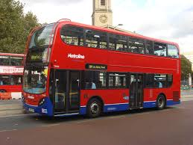)

Remembered:  (or maybe thought bubble?) *

Sister: A bunch of people (stickfigure esque), Parents, kids, 2 girls are circled (they’re the sisters!)*

Buying: Holding out item (food?), coins dropping into hand

Necklace, it’s a necklace

Birthday Party: Cake, balloon, party

Hong Kong: Hong Kong flag? Map of China, w/ arrow pointing to Hong Kong? *

Winter: Show small depiction of each season, including trees. Summer: tree has all leaves. Fall: Leaves are orange, some on ground/falling. Winter: No leaves, tree has snow on it. Spring: Tree is budding, some leaves. The winter part is circled. *

Year: 12 calendar icons (months), arrow from last to first*.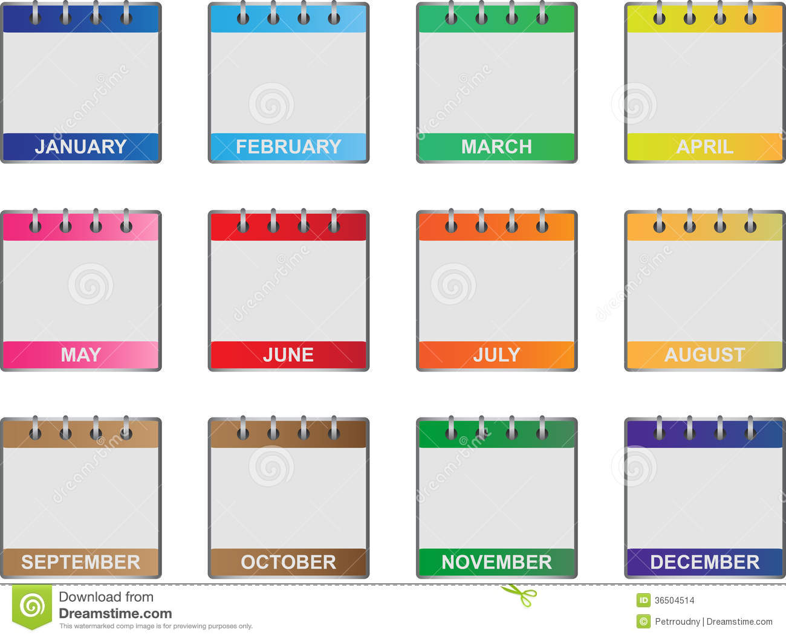

*Past* adjective: Timeline showing cavemen, castle, and then computers/phones, Arrow above it going backwards.